SIMATS ENGINEERING (SAVEETHA SCHOOL OF ENGINEERING)
Department of Computer Science and Engineering

ASSESSMENT TOOL 3 – CONCEPT MAPPING

Course Code: | CSA16 |  | Course Title: | Data Warehousing and Data Mining
CO Assessed: | CO1 – Precision (BL2, BL3, BL4) |  | Assessment: | Assessment Tool 3 – Concept Mapping
Weightage: | 20% of CIA |  | Total Marks: | 100 (5 Questions × 100 Marks)
CO1 Statement: | Design data warehouse architectures with appropriate dimensional models for effective decision support systems. BL1, BL2
Student Name: | K . Nagapreetham |  | Reg. No.: | 192525242
Section / Batch: | AIML |  | Date:
Instructions to Students
- Answer the given question through a technical presentation. Total Marks: 100.
- Draw a clear and neat concept map for each question.
- Identify all key concepts and arrange them in a logical hierarchy.
- Show meaningful linkages between concepts using arrows and connecting words.
- Compare related concepts wherever required and justify the relationships clearly.
- Ensure the concept map is well-organized, readable, and properly labelled..
Question Type |  | Focus Area |  |  | Questions Marks
Concept Mapping |  | Decision support system, Operational versus Decision support System, Architecture of data warehouse, ETL, OLAP and data cubes, Dimensional data modelling -star snowflake schemas. Query Processing, Open-source Business Intelligence Tools. Develop an application to perform OLAP operations - Introduction to KNIME tool for reporting. |  |  | Q1,  Q2,Q3,Q4,Q5 | 100
 |  | GRAND TOTAL: |  |  | 100 Marks
SECTION A – Technical Presentation
Concept Map 1: Decision Support Systems (DSS) Task Description:
Construct a concept map that explains how a Decision Support System (DSS) supports organizational decisionmaking.
Core components: Data, Model, User Interface
- Types of DSS
- Flow: Data → Analysis → Decision
- Role in business decision-making
- Real-world example linkage
Concept Map 2: Operational Systems vs DSS Task Description:
Develop a comparative concept map that clearly distinguishes Operational Systems (OLTP) and Decision Support Systems (OLAP).
- Definitions of OLTP and DSS
- Differences (data type, purpose, users, processing)
- Similarities and interactions
- Real-time vs historical data
- Example systems (banking vs analytics)
Concept Map 3: Architecture of Data Warehouse Task Description:
Create a hierarchical concept map illustrating the architecture of a Data Warehouse.
- Data Sources → ETL → Data Warehouse → Data Marts
- Metadata layer
- Front-end tools (reporting, OLAP)
- Data flow direction
- Role of each layer
Concept Map 4: OLAP, Data Cubes & Dimensional Modelling Task Description:
Design a concept map that connects OLAP operations, Data Cubes, and Dimensional Modelling techniques.
- Data cube structure (dimensions, measures)
- OLAP operations (slice, dice, roll-up, drill-down)
- Star schema and snowflake schema
- Fact and dimension tables
- Analytical usage
Concept Map 5: Query Processing & BI Tools (KNIME) Task Description:
Construct a concept map explaining how query processing integrates with BI tools, focusing on KNIME for reporting and OLAP applications.
- Query processing stages (Parsing, Optimization, Execution)
- Role of BI tools
- KNIME workflow structure
- Data → Query → Visualization pipeline
- OLAP application integration

Code of Conduct
I __________________________ (Name / Reg No) certify that this submission is my original work and that I have adhered to the guidelines specified for this assessment. I understand that any violation of academic integrity rules will result in disciplinary action.
Signature of the Student: _________________________

RUBRICS FOR CALCULATION

Criteria Wt. |  | Level 4 –  Exemplary | Level 3 – Proficient | Level 2 –  Developing | Level 1 –  Beginning
Concept  Identification | 25% | Identifies all key concepts from  literature accurately and comprehensively | Identifies most key concepts with minor omissions | Identifies limited concepts; some are irrelevant or missing | Fails to identify essential concepts
Linkages | 25% | Establishes clear, meaningful, and accurate relationships between concepts | Shows correct relationships with minor gaps | Relationships are weak, unclear, or partially incorrect | No meaningful relationships established
Organization | 20% | Concepts are wellstructured hierarchically with logical flow and grouping | Mostly organized with minor structural issues | Some  organization but lacks clear hierarchy | No logical organization or structure
Integration of Literature | 20% | Integrates multiple studies effectively to show connections and comparisons | Shows some integration of literature | Limited integration; mostly isolated concepts | No integration of literature evidence
Clarity | 10% | Concept map is clear, neat, visually structured, and easy to  interpret | Generally clear with minor readability issues | Clarity is reduced; difficult to interpret in parts | Poorly presented and hard to understand
Marks Evaluation:
Questio n No. | Concept  Identification (25%) | Linkages (25%) |  | Organizatio n (20%) | Integration of  Literature  (20%) |  | Clarity (10%) | Total  Marks  (Each –  50)
Q1
Q2
Q3
Q4
Q5
 |  |  |  |  |  |  | Overall Total (100)
Faculty In-charge |  |  | Course Coordinator |  |  | Head of Department
Signature: _______________ |  |  | Signature: _______________ |  |  | Signature: _______________
Date: ___________________ |  |  | Date: ___________________ |  |  | Date: ___________________

Concept Map 1: Decision Support Systems (DSS)
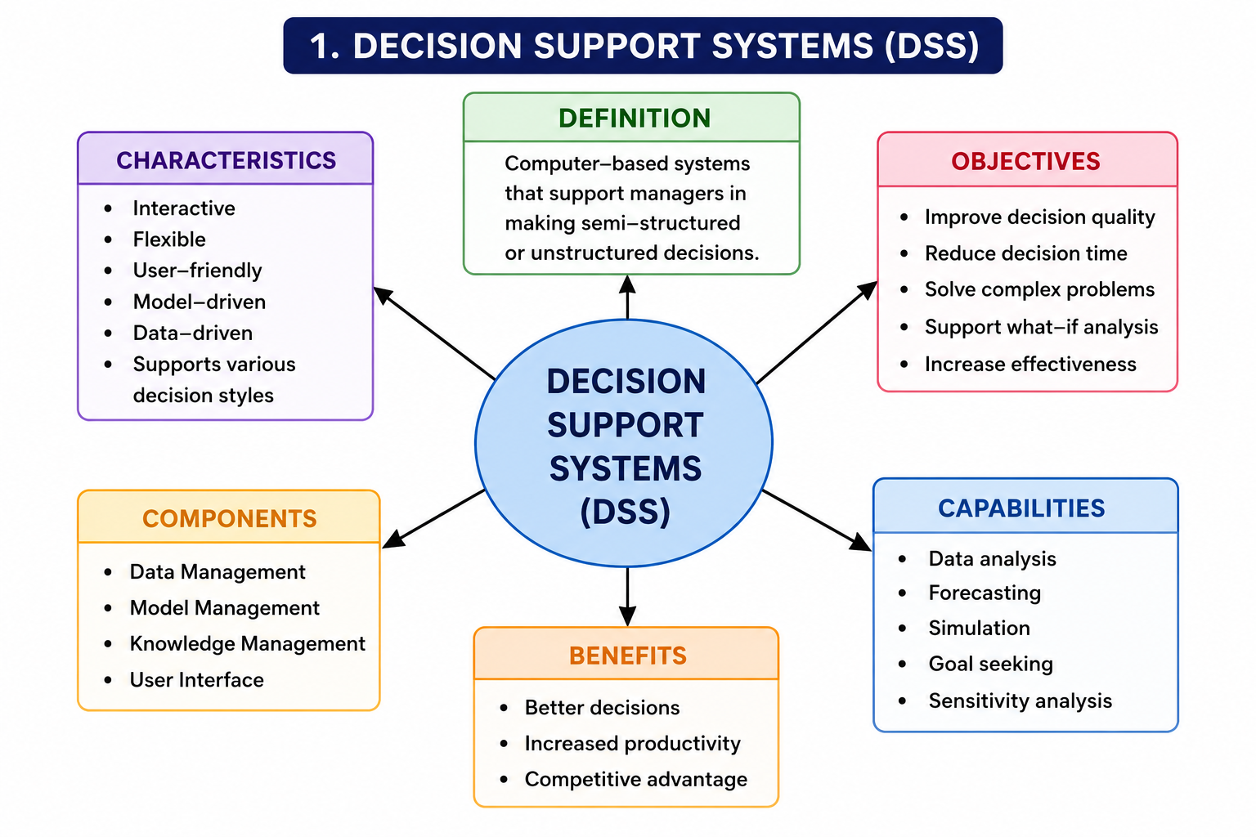
Concept Map 2: Operational Systems vs DSS
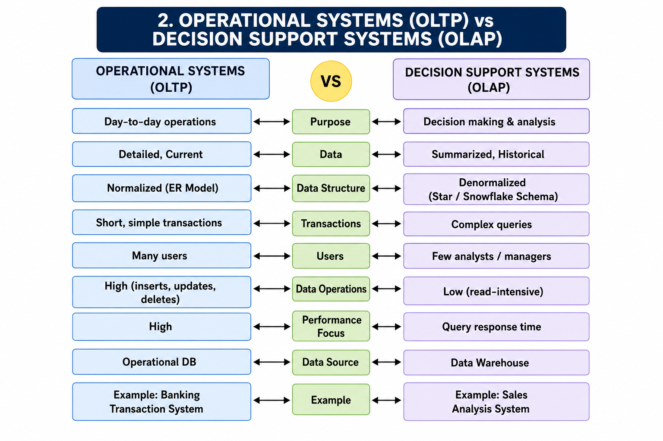

Concept Map 3: Architecture of Data Warehouse
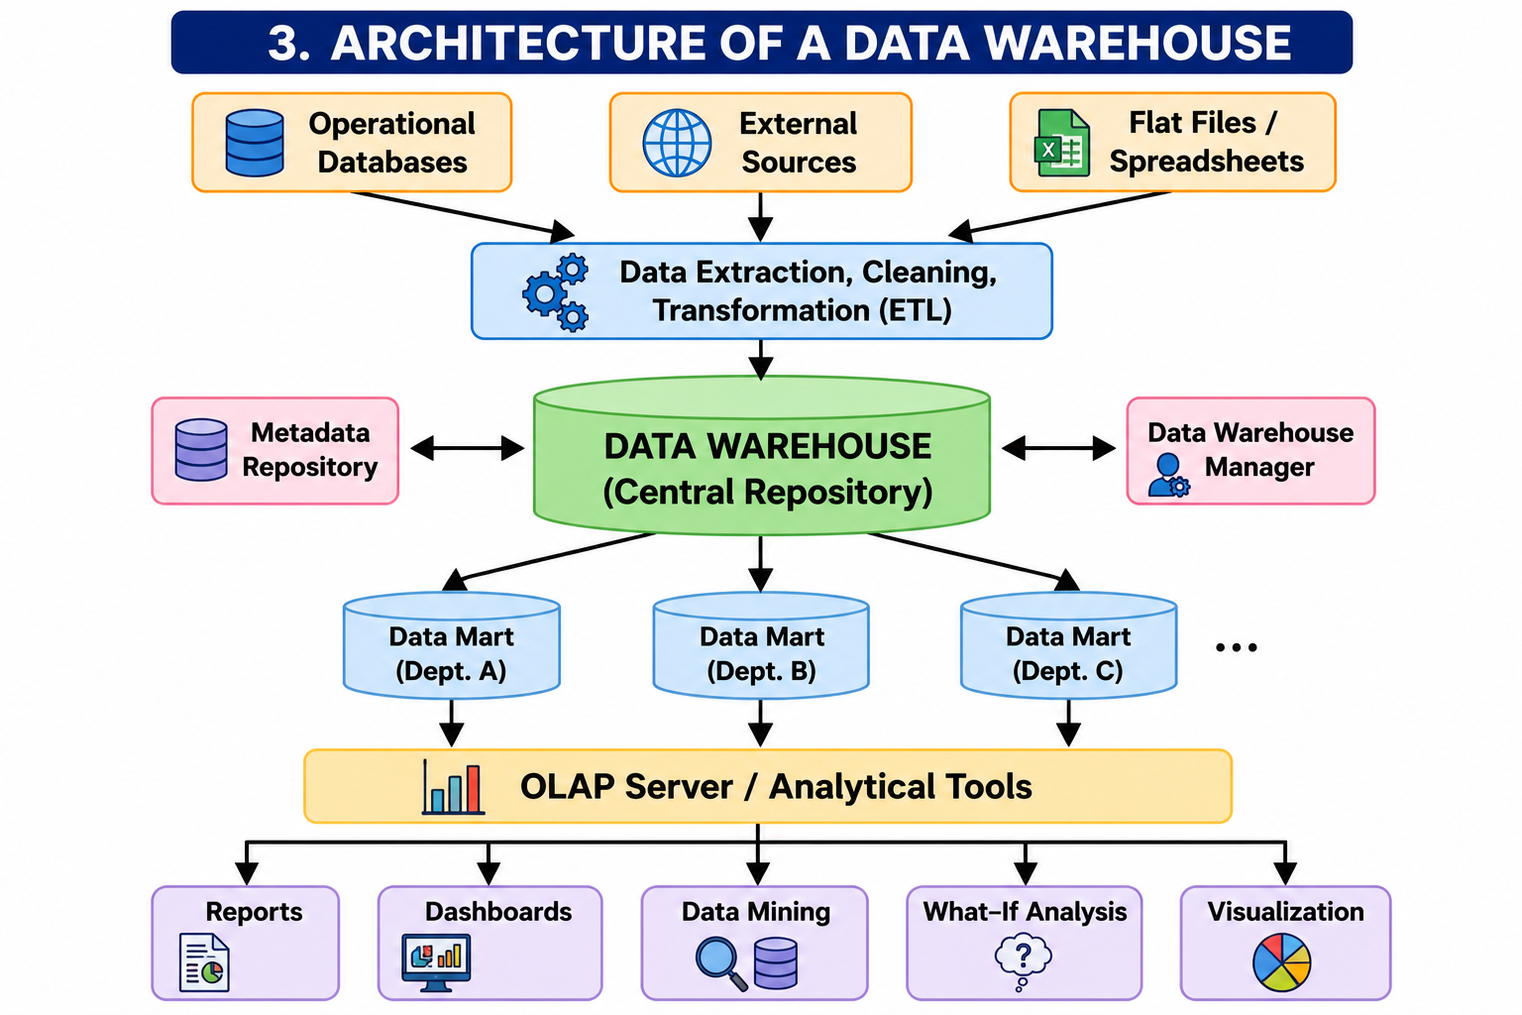

Concept Map 4: OLAP, Data Cubes & Dimensional Modelling

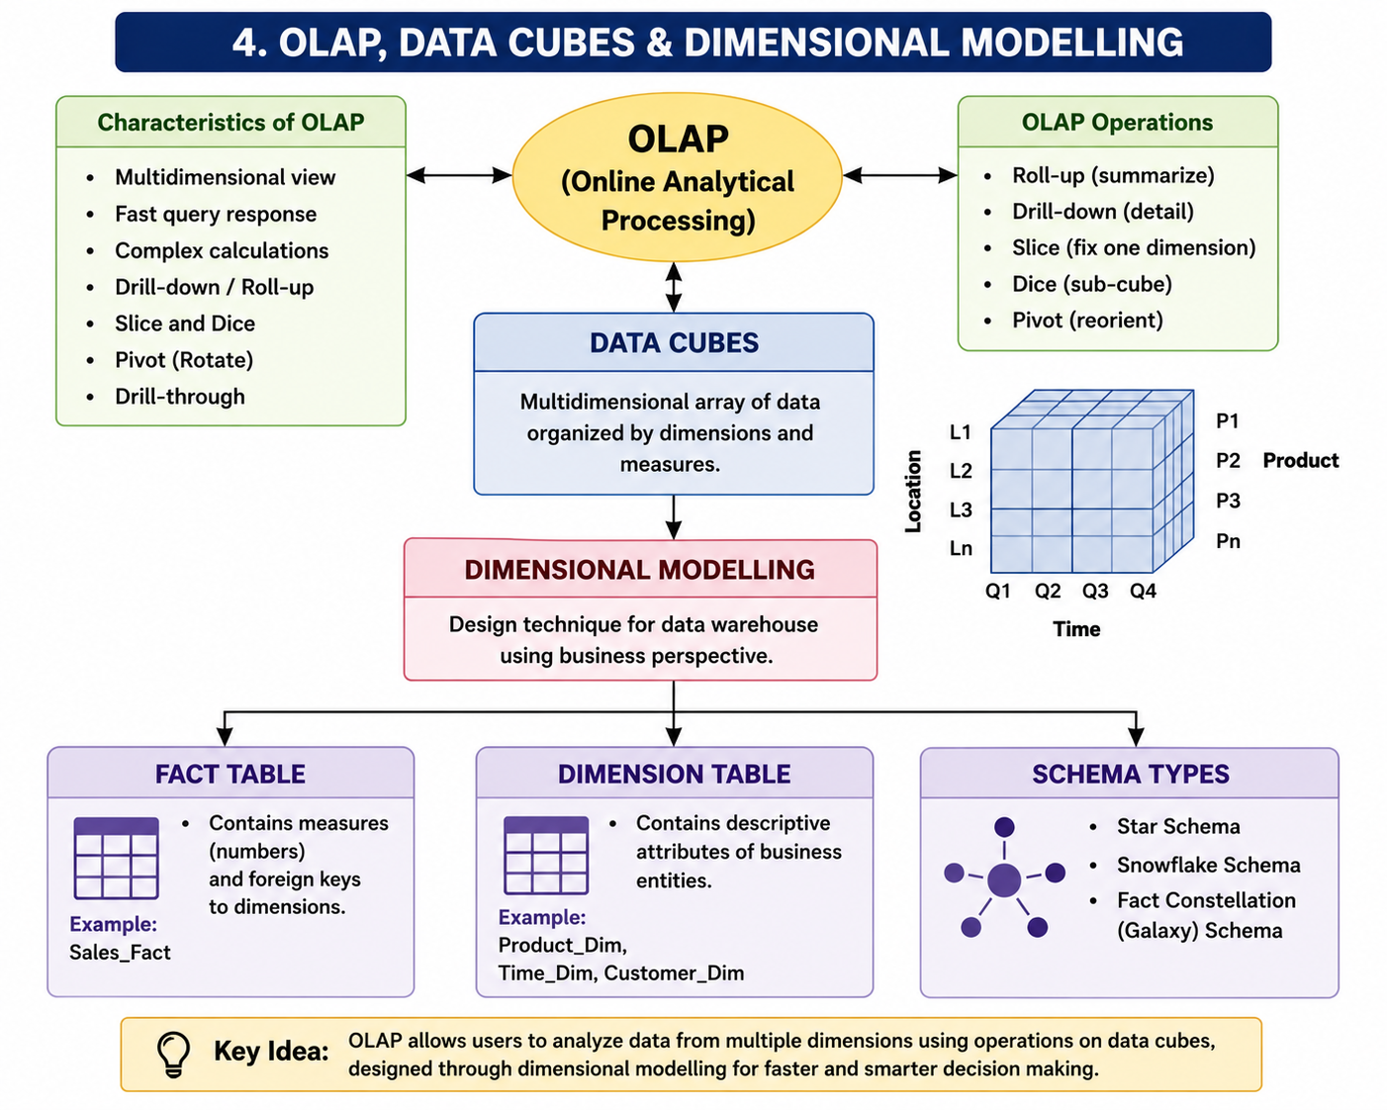

Concept Map 5: Query Processing & BI Tools (KNIME)

